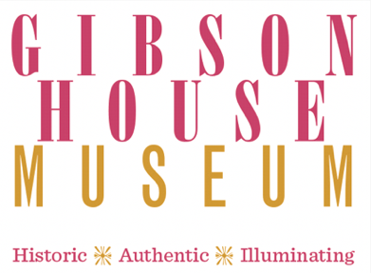

Massachusetts History Day 2022
Debate & Diplomacy in History: Successes, Failures, Consequences
Resources for Research*
- Papers of Charles Hammond Gibson, Jr. (1874-1954)
  - Themes: Travel literature, international diplomacy & goodwill, debates over public space
- Papers of Mary Ethel Gibson (1873-1938) & Freeman Henry Allen (1870-1930)
  - Themes: Military medicine, travel abroad, debates over women’s suffrage
- Material culture at the GHM (includes furniture, decorative arts, architecture, etc.)
  - Themes: Transnational decorative arts, travel souvenirs, immigration & domestic service
*Linked are one example per theme. There is much more to be discovered in the collection!
- About the Gibson House Museum
The Gibson House is a historic house museum in the Back Bay neighborhood of Boston, which housed three generations of Gibson family members and their employees between 1859 and 1954. The Museum’s four floors of period rooms serve as a time capsule of domestic life in the 19th and early 20th century. Guided tours interpret class and culture through the stories of the people who lived and worked in the house.
In addition to the collections on view, the Gibson House Museum manages an archive and photograph collection. The archive consists of approximately 25 linear feet of original material related to the Gibson family, including daily journals, scrapbooks, correspondence, and both published and unpublished manuscripts. The Museum has a related collection of approximately 1,500 photographs from individual family photograph albums.

The Gibson House Museum
137 Beacon St. Boston, MA 02116
617.267.6338
www.thegibsonhouse.org

